Dani Arthur Widodo
System Developer / Software Developer / Web Developer
Telephone + Whatsapp : +62 81341047147 | email: work.daniarthurwidodo@gmail.com / dani.widodo87@gmail.com | Linkedin: https://www.linkedin.com/in/daniarthurwidodo/

Profile Summary
👋 Hardworking, Problem Solving and Enthusiastic Software Developer. 🌍 I am an experienced software developer with a strong background in working for international multicultural companies. With over 8 years of hands-on experience, I thrive in dynamic and collaborative environments that foster innovation and growth.
💻 Throughout my career, I have gained deep expertise in Laravel, Angular, React and Node.js, constantly pushing the boundaries of what's possible in web development. I am driven by a curiosity to explore emerging technologies and best practices, ensuring that I stay up-to-date with the latest advancements in the industry.

Work Experience
Krom Bank , February 2024 - current
Technology : Wordpress, Nextjs, Bitbucket, Docker, AWS S3
Role : Senior fullstack developer
Project :
- https://krom.id/
  - build pipeline for krom.id website to deploy in prod + staging in bitbucket in my first 2 weeks
  - revamp website footer + menu
  - develop whistleblower system
  - develop fullstack internal tools krom dashboard with nextjs
  - develop krom unfold with reactjs + aws s3 + with integration to native app

Allianz Indonesia , Jan 2023 - February 2024
Technology : Angular, Java Spring boot, jenkins, docker, flutter, bootstrap
Role : Senior frontend developer
Project :
- eAZy connect
  - Improve live image capture with ngx-webcam to integrate with opencv.js
  - Encrypt credit card number for non-login feature

- eAZy pension
  - upgrade angular from angular 9 to 12
  - revamp app to current design
  - implement mobile first and responsive using bootstrap and css
  - create custom translation using json file
  - implement mfa ( multi factor authentication ) integration with SHA256 encryption for device fingerprint
  - create otp component for login with mfa method

Qualysoft , Mar 2022 - Mar 2023
Technology : Angular, dotnet, jenkins, docker, nx micro-frontend, primeNG
Role : Senior frontend developer
project :
- coretax
  - build form generator for generating 3500 unique forms due to different template in each tax office branch by building app that generate custom table in database with dotnet and custom reusable angular component by uploading excel file.
  - build pages for module npwp
  - integrate taxpayer with immigration

DIGIkreatif, Feb 2019 - Mar 2022
Technology : laravel, react, vuejs, Express, Hyperledger Explorer
Role : tech lead + software developer
- Develop and Maintain https://www.asninstitute.id/ using Laravel
- Revamp free trial components from laravel Blade to Reactc
- Maintain for domain and subdomain with Cpanel

Kabar Makassar, May 2019 - Mar 2020
Technology : cakephp, bootstrap
Role : web developer
- Develop and Maintain https://www.kabarmakassar.com/ CMS using cakePHP
- Create Ads Module
- Maintain for domain and subdomain with Cpanel

Radio Cristy, Nov 2012 - Feb 2019
Technology : icecast, ionic, angular, linux
Role : web developer
- Design, Develop and maintain https://apkcombo.com/id/radio-cristy-828-am-makassar/makassar.radiostreamingV2.cristy/ for listening radio through internet and read information using Ionic, Firebase, Icecast server and Butt.
- As an IT support to do maintenance such like installing PC and Laptop and setup it with audio interfaces

Al Azhar Junior High School, 2012 - 2013
Technology : wordpress
Role : web developer
- Design, Develop and maintain https://daring.alazharmandiri.sch.id/ for school registration and elearning using wordpress and moodle

Primagama, 2010 - 2012
English Tutor
- Teaching English for various student from first elementary school grade to third high school grade

Education
Tadulako University | 2006 - 2011
GPA 3.12
Bachelor of Arts English Literature and Education

Skill
- Javascript
- Typescript
- CSS
- Bootstrap
- Tailwind
- PrimeNG
- Nx Micro Frontend
- Laravel
- PHP
- ExpressJS
- NestJS
- NodeJS
- mySql
- Postgres
- MongoDB
- VScode
- Figma
- Unit test
- Docker
- Linux
- Microservices
- RabbitMQ
- JIRA
- GIT
- Agile / scrum
- Ionic
- Cpanel
- Digitalocean
- Wordpress
- Angular
- Sonarqube
- Jenkins
- Redis

Licenses and Certificate
- Angular Certificate
- Bootstrap Certificate

Portofolio
- https://www.asninstitute.id/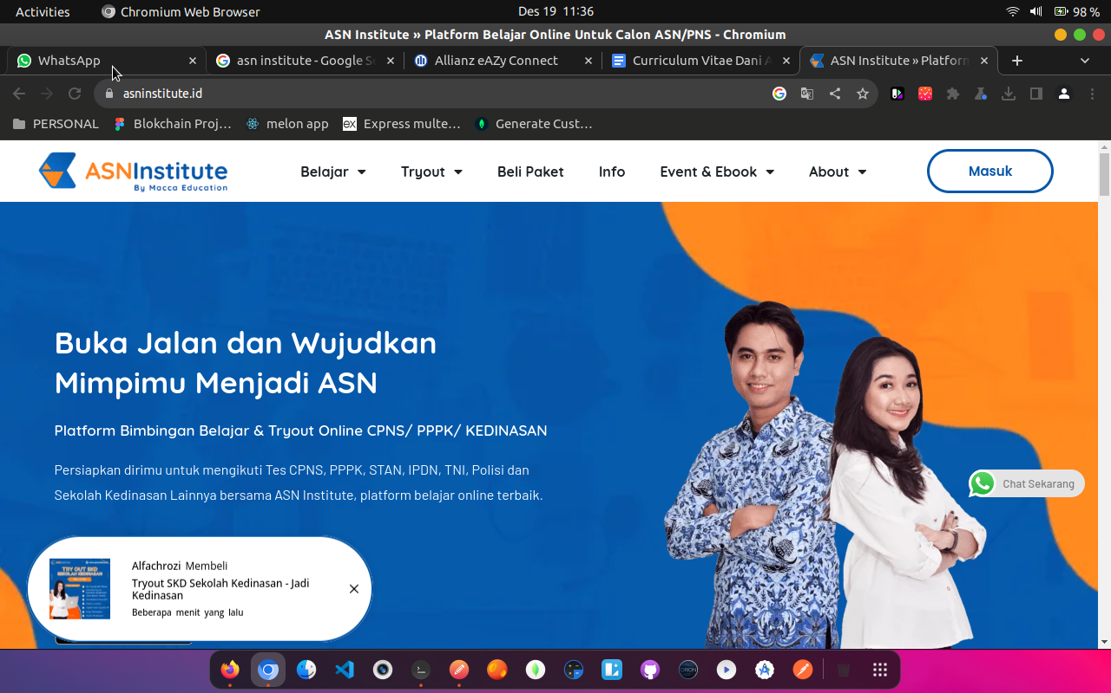
- https://services.allianz.co.id/eazyconnect/in-ID/#/portal/login
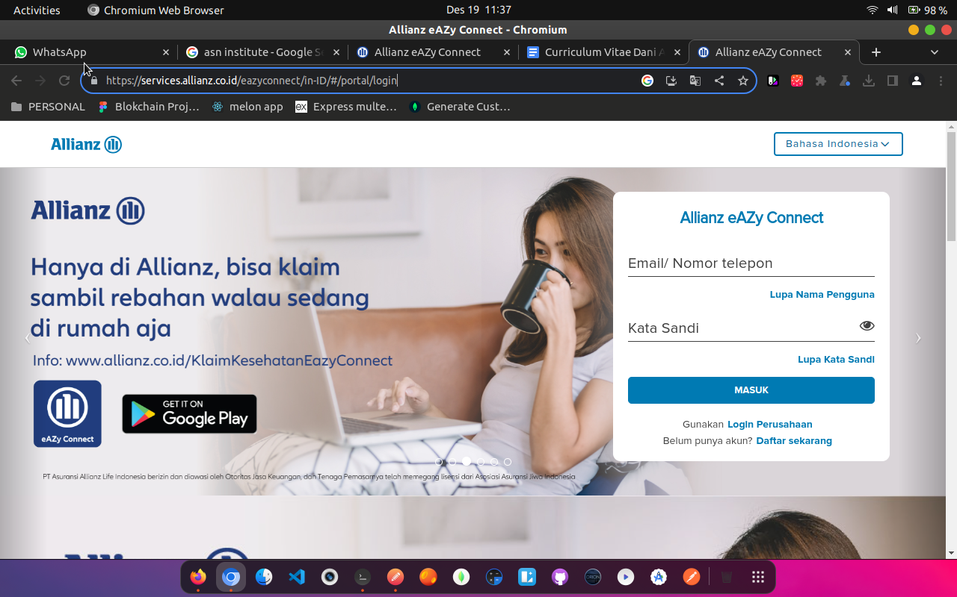
- https://www.kabarmakassar.com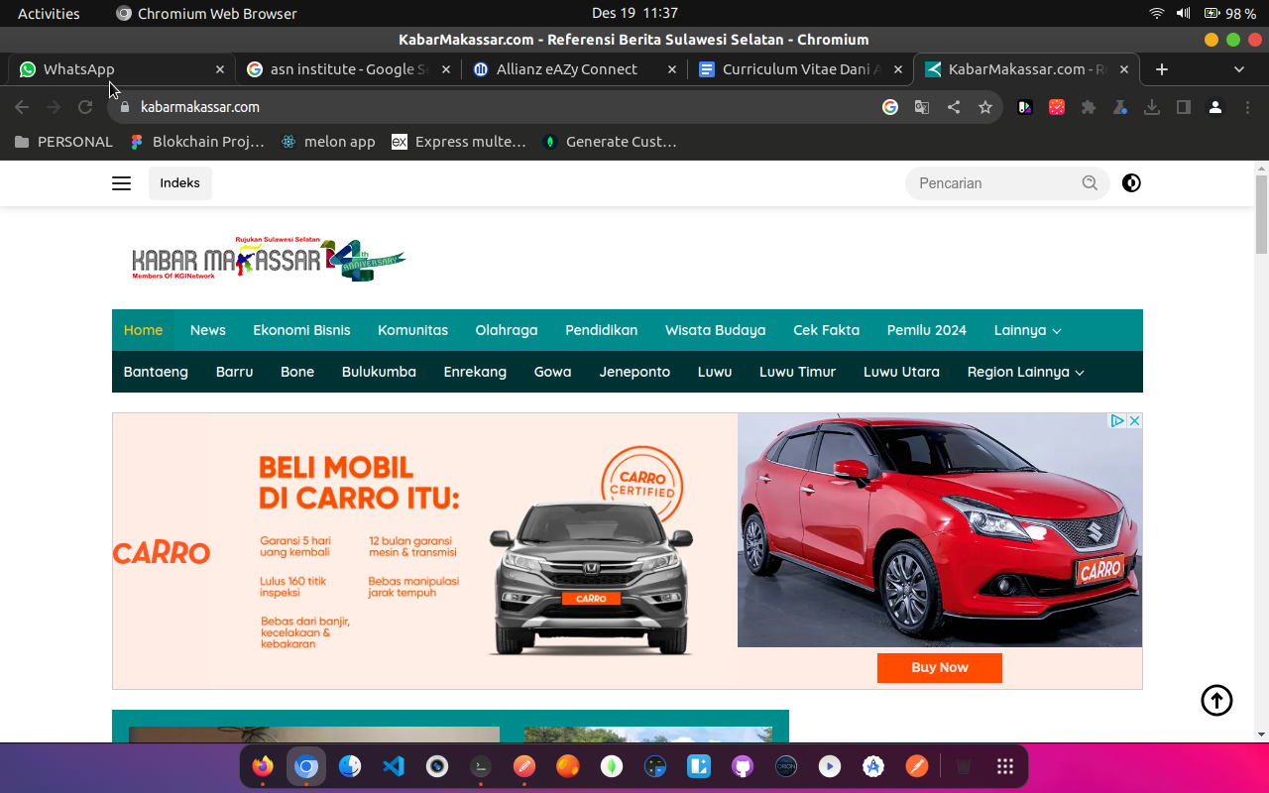
- krom.id


